A2028-**Eur-Germany-Vogelherdhöhle-Horse Figurine-Ivory-Middle Paleolithic-**40,000 BP

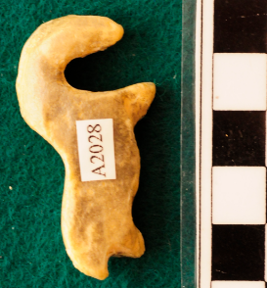 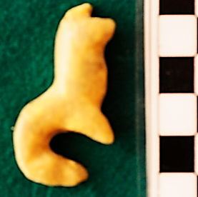

**Eur-Germany-Vogelherdhöhle-Horse Figurine-Ivory-Middle Paleolithic-**40,000 BP

**Case No.:** 1.

**Accession Number:** A2023

**Formal label: Eur-Germany-Vogelherdhöhle-Horse Figurine-Ivory-Middle Paleolithic-**40,000 BP

**Display description:**

Vogelherdhöhle (“Bird-Heart Cave”) was probably named for its location above the Lone River which attracted birds and its heart-like structure, since it has three chambers like a heart. It is among the most significant German Paleolithic sites figurine, dating to 40,000 BP-29,000 BP, exhibits the shape of a round-bellied, short-legged, sandy-beige mares [Przewalski's](https://phys.org/news/2011-11-przewalski-wild-horses-gallop-life.html" \l "nRlv) horse **as reconstructed from its surviving lineage as preserved in the** Prague zoo which has been breeding these sturdy animals since 1932 in captivity since the last wild horse was seen in Mongolia in 1969.

**:**



[Przewalski's](https://phys.org/news/2011-11-przewalski-wild-horses-gallop-life.html#nRlv) horse after https://3c1703fe8d.site.internapcdn.net/newman/gfx/news/2018/anancientspe.jpg

**LC Classification:** GN772.2.A8

**Date or Time Horizon:** 40,000 BP-29,000 BP

**Geographical Area: Vogelherdhöhle Site, Germany**

**Map, GPS Coordinates:** 48.561321, 10.189116

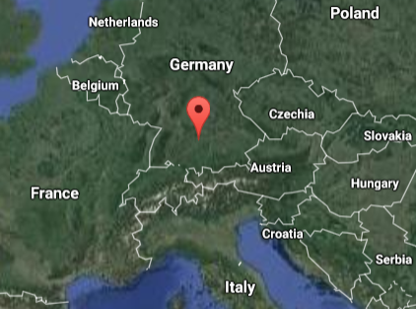

Fig. 3. Location of Vogelherdhöhle in the local landscape.

Fig. 4. Location of Vogelherdhöhle in Germany.

**Cultural Affiliation:** Aurignacian

**Medium:** mammoth ivory

**Dimensions:   
Weight:**

**Provenance: original,** Museum Schloss Hohentübingen, **Tübingen.**

**Condition:** museum replica in resin**.**

**Discussion:**

On 23 May 1931 Hermann Mohn, a private researcher from Heidenheim, while probing the hills near Stetten bei Niederstotzingen for prehistoric remains, found flint artifacts in the rear of a badger den, which he named “Mohnloch” (“Mohn’s hole”). He informed the prehistory department of the University of Tübingen of a potential Paleolithic cave, and Tübingen sent a junior researcher, Gustav Riek, to Stetten to inspect the site. The Y-shaped cave has three openings (S, SW and N) and covers 170 m2. Mohn and Riek squeezed through the 30 cm x 40 cm opening into the badger den and on the evening of the second day they found the Paleolithic evidence they were looking for: Mohn’s hunch was right, and when this was confirmed Tübingen renamed the cave “Vogelherdhöhle,” “Bird-Heart Cave,” for the way the waters of the Lone River attracted birds and for the cave’s three cavities that resembled the three chambers of a heart. Then, Riek excavated the entire cave in just three months. Small artifacts escaped detection and were jettisoned into large back-fill mounds. In the intervening years these mounds have been thoroughly re-examined and many discarded artifacts have been recovered, but they were now without any contextual information.

Vogelherdhöhle has four Middle Paleolithic strata and four Upper Paleolithic strata of which two layers V and VI belong to the Aurignacian, in which eleven figurines, like the present artifact, were found. Two other cultural strata include the Magdalenian and the Neolithic but the Gravettian is missing. The lower Aurignacian layer V supplied a total of seven figurines, including those of an *Equus ferus przewalskii*  (Przewalski’s horse), a small mammoth, a large mammoth (of which only the rear part and the front leg and neck area were recovered), a headless animal figurine, a *Panthera leo spelaea* (Eurasian Cave-Lion) and an unidentified headless animal with its head now discovered from the excavations in 2012 (Conard et al., 2013). Four figurines from the upper layer IV include a *Panthera leo spelaea*, a *Bison priscus* (Steppe Bison), a mammoth and an anthropomorph. Although the layer in which each figurine was excavated is known, Riek had not recorded their exact positions and their contexts.

**References:**

Bosinski, G. 2013. “Les precurseurs de l'art aurignacien.” In P. Bodu, L. Chehmana, L Klaric, L. Mevel, S. Soriano and N. Teyssandier, N. (eds.), *Le Paleolithique superieur ancien de /'Europe du Nord-Ouest: Reflexions et syntheses a partir d'un projet collectif de* *récherche sur le centre et le sud du Bassin parisien: Actes du colloque de Sens (15-18 avril 2009)* Paris: Sociéte préhistorique française.

Conard, N. J., Zeidi, M. and Bega, J. 2013. “Die letzte Kampagne *der* Nachgrabungen am Vogelherd,” *Archaologische Ausgrabungen in Baden-Wurttemberg,* 2012: 84-88.

<https://phys.org/news/2011-11-przewalski-wild-horses-gallop-life.html#jCp>